**DAILY ONLINE ACTIVITIES SUMMARY**

|  |  |  |  |  |  |  |  |  |
| --- | --- | --- | --- | --- | --- | --- | --- | --- |
| **Date:** | **19/06/2020** | | | | | **Name:** | **SPOORTI DAROJI** | |
| **Sem & Sec** | **4th SEM. & ‘B’ SEC.** | | | | | **USN:** | **4AL18CS088** | |
| **Online Test Summary** | | | | | | | | |
| **Subject** | | **MICROCONTROLLER AND EMBEDDED SYSTEM** | | | | | | |
| **Max. Marks** | | **20** | | **Score** | | | **19** | |
| **Certification Course Summary** | | | | | | | | |
| **Course** | **Introduction to Cybersecurity** | | | | | | | |
| **Certificate Provider** | | | **CISCO** | | **Duration** | | | **15Hrs.** |
| **Coding Challenges** | | | | | | | | |
| **Problem Statement 1:Write a C Program to rotate a Matrix by 90 Degree in Clockwise or Anticlockwise Direction. Implement (Both the rotations in single program using switch case statement).**  **Problem Statement 2:Write a C Program to Count total set bits in all numbers from 1ton** | | | | | | | | |
| **Status: Executed** | | | | | | | | |
| **Uploaded the report in Github** | | | | | **Yes** | | | |
| **If yes Repository name** | | | | | [alvas-education-foundation](https://github.com/alvas-education-foundation)/[spoorti_daroji](https://github.com/alvas-education-foundation/spoorti_daroji) [spoorti_daroji](https://github.com/alvas-education-foundation/spoorti_daroji)/coding_solutions/ | | | |
| **Uploaded the report in slack** | | | | | **Yes** | | | |

**Online Test Summary: 18CS44 online test was scheduled from 3:00 PM to 3:30 PM.The portion for the IA was 4th module there were 20 questions and the time assigned was 30minutes the questions were MCQ type.**

**Online Certification course Summary:**

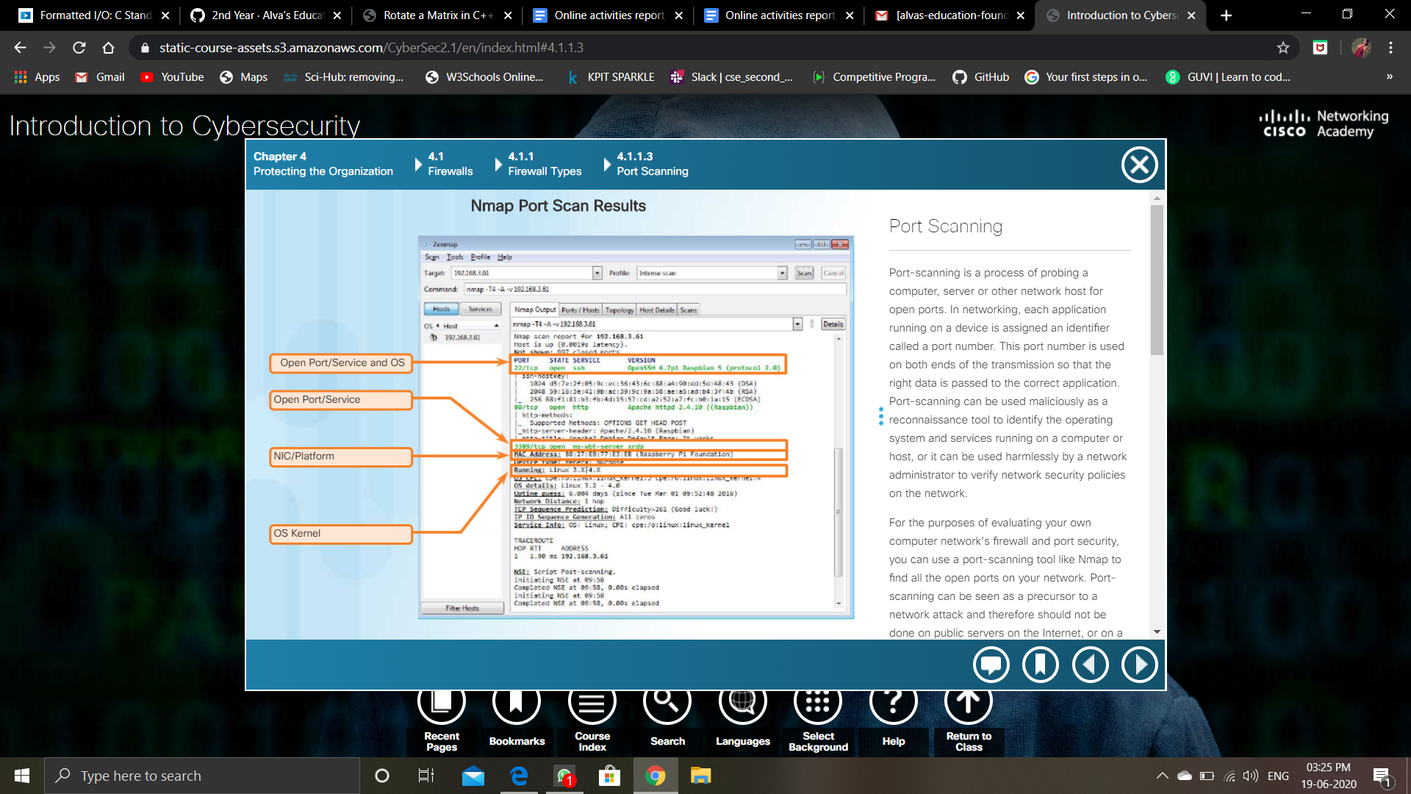

**Online Coding Summary:**

**Today I received one program from prof.Venkatesh CSE Dept and prof.Shilpa CSE Dept. The program is mentioned above in the coding challenges(pg.01). I uploaded it to my Github repository.**

